Nebraska Home Visiting
Part I: Tableau Process for Combining Datasets and Creating Extracts (this is done quarterly)

Initial Set Up (DHHS)

LLCHD (we usually receive their file on the 1st of every month)

Copy original file into master folder located at U:\Master(Files Used for Quarterly Reports)\Lincoln Lancaster County Health Department\Y**Q*

Cut into U:\Working > Tableau > Y** > quarter > LLCHD folder

Separate each tab into separate files, keeping the naming logic of the tabs BaseTable_20**Month, (ex. BaseTable_2021Oct) WellChildVisits_20**Month, MaternalIns_20**Month, ChildERInj_20**Month

If the value of NULL is in fields, find/replace NULL strings to be empty
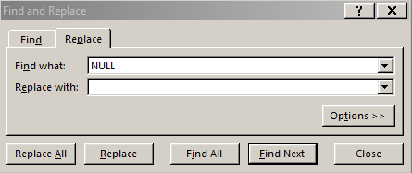

Open the base table file and
- Recode site_id to ll (lower case L’s)
- If the tgt_id is blank use a 0 as a placeholder.
- Concatenate project_id using =CONCATENATE(B2,D2,"-",E2)
- Filter discharge_dt (Column AC) for families that terminated before the current reporting year remove these families.
Also filter and remove families that don’t have a home visit in the current fiscal year (last_home_visit - Column AD).
Also filter and remove families that have 0 home visits (home_visits_num - Column AE).
- To remove the timestamp on all of the dates use the replace feature and put a space then a ‘ *’ to remove the timestamp. (Do this for each dt column) *** did this at the end
- Save as v2

Save as ID file

Remove all variables except project id variables, enrollment and discharge variables, funding, names, dobs, address, ssn, home visit number, and tgt gender. Keep FOB variables as well. (Easiest to look at previous quarter – Columns end up as A-Z)
*Note: A lot of LLCHD’s variables are coming through with a timestamp to remove these simply go to replace and put a space and a * ‘ *’ then hit replace all this will get rid of the timestamp (Note: Check this is only impacting dates and not other fields. May need to go column by column)

FamilyWise (We usually receive their file on the 7th or 8th of the month depending on the day)

Copy original file into master compressed folder

Copy original Access file to the master folder

Copy Access file into working > tableau > year > quarter > family wise

Connect to queries
- Open data file and immediately save as “Y6QX Data and Query”. Close and open the new version.
- Select “External Data” tab > select “Access” within the Import and Link section
- Keep the button for “Import tables, queries, forms, …”
- Go to the most recent quarter’s Data and Query should be labled to the effect of Y**Q**Data and Query
- Under the tables tab, select the following Make Tables:
- 15 Caregiver Education Make Table 2
- F1 - Employment Make Table
- F1 - Marital Status Make Table 2
- F1 - Misc Make Table
- Site IDs
- Under the queries tab Select All. Click okay.

Create make tables
- Right click the 15 Caregiver Education Make Table 2 query and select design view - do not double click the query name
- Click the ! Run button in the top left to run the report. It will give you an alert that “the existing table [name] will be deleted before you run the query”, click yes, this means you are replacing the existing table with the new one. It will then give you an alert “you are about to paste # rows into a new table”, click yes. This alert indicates you’ve successfully written the table.
- Close the query without saving it - if you save the query after running it, it will disappear.
- Open the table that was just created (the table, not the query) and check the dates to ensure that new data was brought into the table. If there are only dates from the previous quarter, it did not take.
- Repeat these steps for 15 Caregiver Education Make Table 2, F1 – Employment Make Table 2, F1 – Marital Status Make Table, and F1 – Misc Make Table.

Export “ID File” query (right click > export > Excel > save under Working/Tableau/Y6/Quarter/Family Wise)

Add AutoNum field to Referrals table – open the Referrals table in Design View and Insert Row. Enter Field Name “AutoNum” and Data Type “AutoNumber” and save
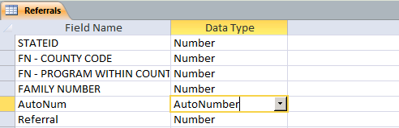

For Q1,check date filters are set for current fiscal year on the following queries: 08 Child ER Injury, 11 Early Literacy, 13a Behavioral Concerns, F1 - Home Visit Type a, Home Visits Prenatal and Total Part 1

Export the following queries and save them as titled under Working\Tableau\Y6\Quarter\Family Wise (Note: adult activities takes about 18 minutes to run and child activities takes about 10 minutes to run)
- 04 Well Child Visit v2 no MAX
- 08 Child ER Injury
- 16 Caregiver Insurance v2 – USE THIS ONE
- Child Activities
- Adult Activities
- Adult UNCOPE
- F1 - Home Visit Type Query
  - Update to create Virtual to IP (In Person) vs V (Virtual) = Total
- Referral Exclusions 1 thru 6
  - Note: Don’t need Referral Exclusions 4 for Child Activities. It’s in 1 thru 6
  - (Note: These are in a specific order and #4 is on the child activities). When you get the error below go into each of the “- Select” referral queries and delete the “Expr1:” just leaving “AutoNum”. Leave the other Expr column as is.
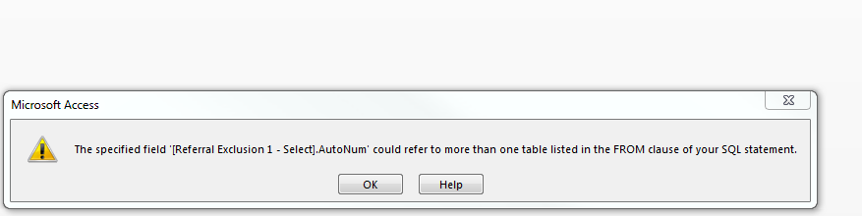
If you get this message, leave blank and click OK
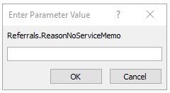

ID File (DHHS a and b CPPR c and d)
Note: a combined ID file is created each quarter. Each quarter the data is replaced with current data, unlike the benchmark data which is added to the dataset rather than overriding quarter by quarter.

Open the FW ID export and remove any rows with a discharge date before the current reporting year, rows that do not have an enrollment date, and rows that have 0 # of MAX home visits, may need to update ZIP Code to remove -_ symbols

Update Combined ID File
- Open the Combined ID File excel sheet held under working > tableau > y6 and remove the data from all sheets, keeping the headers
- Copy the FW ID file data and paste into the appropriate tab, ensuring labels line up
- Copy the LLCHD ID file data and paste into the appropriate tab, ensuring labels line up
- Copy all project IDs from the FW and LLCHD tabs and paste into the Project ID tab. Deduplicate ids. Data tab > Remove Duplicates > Click OK.
- Save. Do not save as a new version.

Update Tableau file
- Open the Tableau ID File workbook and refresh the data (should happen automatically but verify) – U:\Working\Tableau\Y11 (Oct 2021 - Sept 2022)\Y11Q1 (Oct 2021 - Dec 2021)\Tableau Queries
- Check for oddities (red exclamation marks next to variable names) and “unrecognized value”

Export data
- In Tableau ID file, move into the sheet view
- Right click on the data source icon at the top left and select view data
- In the popup, select all data by clicking the box to the left of the column labels and above the row labels (see below)
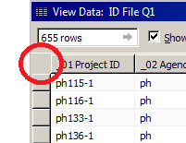
- Select the copy button on the top right of the popup
- Paste the data into an excel file (use the previous quarter’s ID file as template. Keep the variable names in template not the Tableau variable names (row2))
- Remove all columns past “_26 Zip” variable
- (Step looks no longer needed FY23Q1) Find LLCHD records highlighted in Combined ID File in this new file. Change the funding variable from CHE to F-3
- Remove duplicate Project IDs
- Save exported file under Working\Tableau\Year\ID Files
- Copy the old variable names from the previous file and overwrite the headers in the new file (not needed if you used the previous quarter as template)

CPS File Creation

CPS ID File Creation (FY23Q1)
- Open previous quarter’s “ID File for CPS”
- Rename all of ord1 (column A ) to “Old-record do not process”
- Paste in all the new records but only those variables listed (columns B - L)
- For new records, rename ord1 (column A) to “New-record process”
- Remove any records that don’t include a TGT First and Last Name. Remove any records will a name of “null”
- Sort file by project_id and ord1 (Z-A)
- Notify N-DHHS partners that the file is ready with the location

(Not sure if this is still the process) Combine the last file that you received from CPS with the current ID file created in the step above. Remove the families that include just the mom’s information (the baby hasn’t been born yet). Please see the table below for the variables that need to be included in the file sent to CPS and their location.

Variable name | Location
Ord1 | Put new record process on the ID file put old record do not process on the old CPS records. Generally done before transferring them together.
Project_id | ID file
Tgt_first_name | ID file
Tgt_middle_name | Note this will be missing on the ID file but will be on the old CPS file that is fine
Tgt_last_name | ID file
Tgt_dob | ID file
Mob_first_name | ID file
Mob_last_name | ID file
Mob_dob | ID file
Address | ID file
City | ID file
Zip | ID file
Person Number | CPS file
Intake Number | CPS file
Current Status Reason | CPS file
Intake Received | CPS file
Intake Role | CPS file
Classification | CPS file
Finding | CPS file
Physical Abuse | CPS file
Physical Neglect | CPS file
Emotional Abuse | CPS file
Emotional Neglect | CPS file
Sexual Abuse | CPS file
Medical Neglect | CPS file
Sex Trafficking | CPS file
Labor Trafficking | CPS file

Who receives the CPS file? Steps here?

HSS sends to Anamika Jha, Jacob Clark, and Jake Malone. Anamika Jha and Jacob Clark may be changing soon, Jake Malone will not.

Benchmark Files (DHHS)

LLCHD prep

Open latest version of the base table file and remove identifying variables– first and last name of tgt, mob, and fob; SSNs of tgt, mob, and fob; address; and city.

Leave zip.

What do we think about removing last_home_visit dates before the current fiscal year? We do this for FW and there are some for LLCHD too. (Removed for Y11Q2) – Remove it!

What about worker_id? Remove it!

Save as a new version V2

FamilyWise prep

Child Activity Export
- Remove any rows with a discharge date (TERMINATION DATE) before the current reporting year and rows that do not have a first home visit date (MinOfHVDate).
- Remove any rows with a MaxofHVDate before the current report year. Note: The Discharge Date (TERMINATION DATE is the name) should be in the current report year but families may not have been served in the report year and considered inactive
- Save as a new version v2

Adult Activity Export
- Remove any rows with a discharge date (TERMINATION DATE) before the current reporting year and rows that do not have a first home visit date (MinOfHVDate) and/or rows that do not have a first home visit (Max Visit Number is 0 or blank).
- Remove any rows with a MaxofHVDate before the current report year and has a Discharge Date. Note: The Discharge Date should be in the current report year.
- Save as a new version v2

Referral Exclusion Export and Integration into Adult Activity and Child Activity
- Complete the VLOOKUP in either order (Adult or Child) first
- Open the Referral Exclusion file then you’ll add the VLOOKUPs to the Adult and Child Activity spreadsheets
- Adult - In the last column, use VLOOKUP to pull exclusions 1, 2, 3, 5 , and 6 into the Adult Activity spreadsheet (Note: Exclusion 4 is on the Child Activity export)
  - =VLOOKUP(A2,'[Referral Exclusions 1 thru 6.xlsx]Referral_Exclusions_1_thru_6'!$A$2:$J$2741,5,FALSE) this works if you have the file open otherwise it is more difficult and you have to type the exact location of the file which is longer. – Update the VLOOKUP Range, it won’t be the same as above
    - Note: The rows will need adusted in the VLOOKUP
  - Columns 5, 6, 7, 9, and 10 need pulled into Adult Activity
- Child - In the last column, use VLOOKUP to pull exclusion 4 into the Child Activity spreadsheet
  - =VLOOKUP(A2,'[Referral Exclusions 1 thru 6.xlsx]Referral_Exclusions_1_thru_6'!$A$2:$J$2151,8,FALSE) – Update the VLOOKUP Range, it won’t be the same as above
  - Column 8 is the only one to pull into Child Activity
- Copy the columns and paste values in the next column over – this removes the formulas and keeps the values
- Then remove “0”s with Find/Replace so they are NULL
- Save as new version v3

Child Activity ZIP Code
- Complete VLOOKUP on Child Activity for ZIP from Adult Activity (Is this needed anymore?)
- =VLOOKUP(A2,'[Adult Activities Query v3.xlsx]Adult_Activities_Query'!$A$2:$CJ$528,82,FALSE)

UNCOPE Inclusion
    - Open the UNCOPE Export.
    - In the UNCOPE export, copy/paste the UNCOPE columns near the front, only leaving the Project ID in column A.
      - These would be columns Q – Y.
    - In the front of the Adult Activity file, insert the needed number of columns to pull the UNCOPE info (should be 9). Leave column A as Project ID.
    - In the first UNCOPE column in the Adult Activity, enter the VLOOKUP formula. It should look something like this:
      - =VLOOKUP(A2,'[Adult UNCOPE Query.xlsx]Adult_UNCOPE_Query'!$A$2:$J$2165,2,FALSE)
      - Complete for the rest of the UNCOPE columns 3-10
    - Verify data across the two files to ensure the VLOOKUP is accurate.
    - In the Adult Activity, copy the values and paste values (the actual paste command Paste Values, don’t paste the formula) into the actual UNCOPE columns (should be Column Y – just before the Tobacco variable)
    - Delete the inserted columns at the front of the file as they’re no longer needed
    - Save as new version v4

Virtual Visits Inclusion
    - Open the Adult Acitivty and Virtual Visit export
    - =VLOOKUP(A2,'[F1 - Home Visit Type Query.xlsx]F1___Home_Visit_Type_Query'!$A$2:$E$512,4,FALSE)
    - Subtract IP from Total to get V—happens in the adult sheet ‘HomeVisitTypeV’
    - Save as new version v5

Combine LLCHD and FW benchmark files

For the first quarter: Complete these steps for both the Adult and Child Activities
- Copy data from FW adult/child activities into the second tab of the LLCHD basetable file and save the tabs as “Family Wise” and “LLCHD”.
- Note: both the adult and child use the exact same LLCHD basetable, while FW has separate queries for each
- Note 2: FW Child Activities will need Safe Sleep gaps added – these are old – Can we delete from the file?
- Add year and quarter variables to each sheet
- Create a third sheet called project ID and copy/paste all project ids, quarter, and years from both sites. Remove duplicates (under data tab).
- Save file as Adult Activity Master File or Child Activity Master File under Working/Tableau/Y6

For updating: Complete these steps for both the Adult and Child Activities
- Copy the FW activity data and paste it into the FW tab of the appropriate activities file, below the previous quarter’s data. Add year and quarter variables.
- Copy the LLCHD data and paste it into the LLCHD tab of the appropriate activities file, below the previous quarter’s data. Add year and quarter variables.
- Copy all project IDs from just this quarter from both tabs and paste them below the previous quarter’s data in the Project ID tab. Do not replace the previous quarter’s IDs. Remove duplicates from just the current quarter. Add year and quarter data for these IDs.

Restructure Files (DHHS)

Well Child
- Open FW Well Child query and save as a csv called Y6Q# Well Child
- Insert a column after tgt number and label it “funding”
- Open the LLCHD well child data and copy it into the third column below the FW rows
- Add ll under agency code
and concatenate to get LLCHD ids using =concatenate(b2,c2,”-“,d2)
- Filter by agency codes to fill in funding codes for FW sites (hs and ph are “F”; nc, ps, se, and vn are “S”) *** Manually creating for FW, but maybe not needed (var actually used may be created in final Report).
- Sort file by project ID and visit date.
- Filter for visits that occurred before 10/1/2017 and remove those rows.
- Save and Close this csv before trying to open in SPSS
- Open file in SPSS (File>Open>Data, change file type to “all” to see excel files)
- When pop up appears select next, then under “are variable names included at the top of your file” answer yes, then select next. Select next again. Under “which delimiters appear between variables” mark only “comma”. Under the “text qualifier” mark “double quote” and select next. Increase characters to 25, then click on FamilyNumber and increase characters to 25, then click funding and increase characters to 6, then click the Date and increase characters to 10. Select next. Select finish. Save as a v2.
- Restructure the data by going to Data>Restructure. Select the second option (cases into variables) and select next, move project ID and all other values except the variables over to identifier variable and select next. Leave as Yes and select next again. Under “order of new variable groups” select “Group by index” and select next. Select restructure the data now and select finish.
- Save as v3
- Save as an excel workbook ( .xlxs not .csv) labeled v4
- For first quarter: Copy contents of workbook into a new sheet of the child activities master file and label the sheet Well Child. Add year and quarter variables.
- For subsequent quarters: Copy contents of workbook into the Well Child sheet of the child activities master file below previous quarters data. Do not replace the previous quarter’s data. Add year and quarter data.

Child ER/Injury
- Open FW query and move the visit reason in front of the visit date
- Insert a column after tgt id, label it funding. Add funding for existing data. (hs and ph are “F”; nc, ps, se, and vn are “S”)
- Save as a .csv labeled Y6Q# Child ER Injury
- Copy LLCHD data and paste into the third column below FW data.
Add ll as agency name.
Concatenate to make the LLCHD project ids. Copy the LLCHD project ids and paste value to remove formula.
- Confirm that all rows show ER Visit Reason is 1 or accident/injury.
Delete column.
- Sort by project id and visit date.
- Filter for ER visits that occurred before fiscal year begins (10/1/20##) and remove those records
- Open in SPSS and follow steps h through m above to restructure. The name for this tab in the child activity master file is “Child ER Injury”

Caregiver Insurance
- Open FW query and add a column after tgt id for funding code. Add FW funding codes. (hs and ph are “F”; nc, ps, se, and vn are “S”)
- Move Insurance type in front of the date
- Save as a .csv labeled Y#Q# Caregiver Insurance
- Copy LLCHD data into the third column below the FW data.
Add “ll” for agency code
and concatenate for project ID.
Insert a column B and enter this formula
  - =COUNTIF($A$2:A2,A2) and move to column 4
- Sort by project id and insurance date.
Note: unlike the other restructured data do not remove dates that occur before 10/1/2017
- Check column order against Adult Master File – may need to move Type and Date
- Open in SPSS and follow steps Well Child h through Well Child m above to restructure. The name for this tab in the adult activity master file is “Caregiver Insurance”

Update in Tableau and Create Extracts (CPPR)
Note: All sheets must be updated in the master files before continuing to the next steps. Complete these steps for both the Adult and Child Activities

Updating Tableau Query from year-to-year (done for Y7Q1; go to next header)
- On the data source tab, select Data Source dropdown arrow > Edit Connection
- Find and select the new year’s master file in Excel
- Update each join to connect on the Project IDs

Updating Tableau Query for quarterly data
- On the data source tab, change from an extract to a live connection
- Refresh data and check for joining errors
- Put variables in data source order and check all _variables for ! then check syntax on those. Note: these error variables may not appear in the left column of the sheet view, so check for accuracy on the data source view
- Check calculated demographic variables for “unrecognized value”

Create and Publish Extract
- In the sheet view right click on the data source name at the top left corner.
- Select “extract data”, do not add filters, select extract.
- Right click extracted data source, select publish to server
- Select Connect > (Sign in) > NE MIECHV
- Set Project to NE MIECHV - Tableau Designer
- Set Name to override the existing, matching data source title (Ex: Child Activity Master File)
- WARNING: Do not check “Update workbook to use the published data source”

Partner Files
Note: All sheets must be updated in the master child file before continuing to the next steps.
Complete these steps for both the Child Activities.

Updating CPS into the Tableau Query (DHHS a-q , CPPR r-cc)
- Use the “child” file! Not caregiver
- Copy the “Extraction Data Y# Q# (CPS)” file with – KU Copy
- Concatenate project ids using =concatenate(b2,c2,”-“,d2)
- Delete ID columns – only leave Intake Received Date, Current Status Reason, and Finding
- Turn filter on Status – only keep these values: acc, Accept for Initial Assessment, Accept for Out of Home Assessment, Accept for APS Investigation, Law Enforcement
  - What should we do for “Accept for Placement Assmnt”? Kept
  - “Unable to Identify - Accepted” Kept
- Delete all records without a Status from 2d.
- Keep all old (previous quarter’s) records in the file. If not in file already, go add them.
- Remove duplicates across Project ID and Intake Received Date (oldest to newest)
- Sort by Project ID and Intake Received Date (oldest to newest).
- Save as a .csv and v2.
- Open in SPSS and follow steps under the Restructure Files - Well Child h through Well Child l above to restructure. The difference is these data go into the child CPS master file. The name for this tab in the child CPS master file is “CPS Data”
- **DO NOT PUBLISH THIS DATA SOURCE TO KU’s TABLEAU SERVER**
- Copy entire record list into a new tab in the Child CPS Master File
- Create the project ID by using =concatenate(b2,c2,”-“,d2) (or other cells if the year and quarter variables are already in the file)
- Is this step actually needed or just using the joins with the different data sources? Create the funding, cwa, adaptation, and ZIP VLOOKUPs on CPS Data to FamilyWise and LLCHD – copy variables around to the beginning to match the previous quarter’s layout
  - LLCHD will use funding and CWA columns. FW only uses Adaption (no need for funding)
  - OR!
  - Try using funding variables from the joins:
    - LLCHD: [funding (LLCHD)] and [Has ChildWelfareAdaptation (LLCHD)]
    - FW: [_Funding (use this one)] and [Adaptation (Family Wise)]
- The tabs should be CPS Data, Family Wise, LLCHD, and Project ID.
- The Family Wise and LLCHD tabs will need to be updated with the latest quarter’s data if not already done. Use Master Files. Then update Project ID tab with current Quarter IDs
- Save the file.
- **REPEAT: DO NOT PUBLISH THIS DATA SOURCE TO KU’s TABLEAU SERVER**
- In Tableau Queries folder, open “Child CPS Aggregate Data v3”
- Go to 9. Crosstab then go to Data Source tab and refresh the Live connection.
- Go back to 9. Crosstab and switch Quarter parameter to the correct quarter.
- Right-click a cell (one of the numbers) and Select All. Right-click again and View Data.
- Stay on the Summary tab. Copy this data out to Excel and paste into “Child CPS Aggregate Data Master File”
- NOTE: You may need to paste into Sheet2 tab to organize the data. Sort by columns _Agency Name, _Funding, then _C09 Numerator. Then cut/paste _C09 to column C. Then cut/paste the data into the Sheet1 tab.
- Update the year and quarter variables (Columns A and B) and Save.
- Repeat steps for 9a. Crosstab (First Time) and 9b. Crosstab (Substantiated)
- Go to 9. Agg Bar and refresh (may have to set back to live connection)
- Check the data (ensure only looking at recent quarter)
- Update the Child CPS Aggregate Data data source only Aggregate to Tableau Data Master Files.
  - While on the 9. Agg Bar tab in Tableau Desktop, right-click the CPS Data Aggregate Master File and select Export Data to CSV > Migrated Data
  - Navigate to the Tableau Data Master Files folder for the current project year Example for Y10: U:\Working\Tableau\Y10 (Oct 2020 - Sept 2021)\Tableau Data Master Files
  - Select the file to overwrite: Child CPS Aggregate Master File from Excel on NE Server.csv
  - Save and close.. you’re done!
  - Open the Form 2 report to verify C09 has data for the expected quarter

How to make a Make Table query

Create the regular query if it doesn’t already exist

Copy the query and add “make table” to end of the title

Copy the make table query and add a v2 to the end

Set up the make table

Open the v2 query in design view and select the make table button under query type in the toolbar

Enter the name of the table so it’s the same as the first make table query name (not the v2 version).

Save and close the query. DO NOT RUN THE QUERY.

Reopen the MT v2 query in design view and run it. It should give you a couple alerts, you want the one that indicates the # of rows being written. Close the query without saving. Note: the MT v2 query may disappear. You may have to select run more than once.

Tables to Update Annually in FW Query

08 Child ER Injury the regular query if it doesn’t already exist

13a Behavioral Concerns

Home Visits Prenatal and Total Part1

How to download quarterly reports from Tableau

Open most recent version in tableau verify with KU which one this is.

Select tabs of the pages you want to print to select multiple tabs use the Ctrl key and click on the multiple tabs.

Go to file and select print to pdf to save the reports to a PDF. See screenshot below. Make sure you are selecting the tab without the family numbers on it. 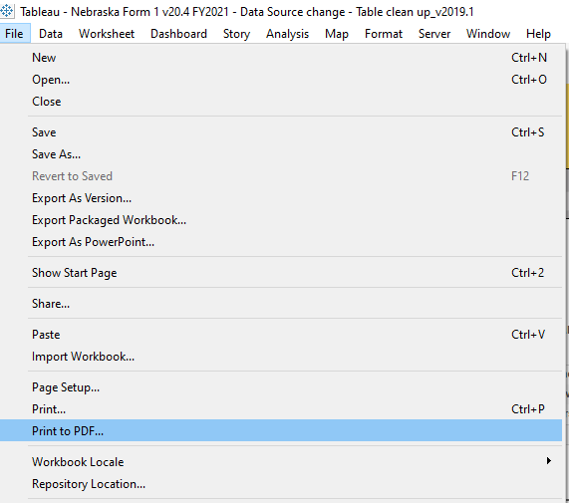

How to find missing data for the LIA’s

Left click on the gray bar as indicated below then you will get what is in the next screenshot.
b. Left click the last button on the right that looks like a grid.
c. The last screenshot will come up and it will default to the summary tab at the bottom left click the full data button and it will bring up the last screenshot.
d. Take the approrpitate data and put it on a excel spreadsheet and distribute to the sites.

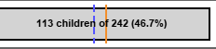

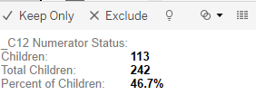
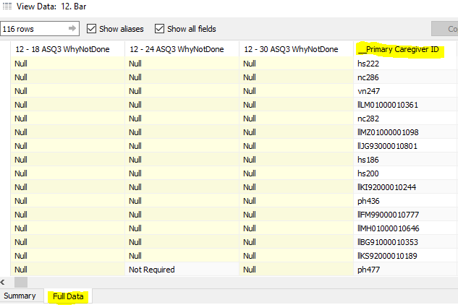

Appendix A: Important Information
Quarters Dates
Q1: October to December
Q2: January to March
Q3: April to June
Q4: July to September

Appendix B: LIA contacts for the reports
LIA | Contact person/s
LLCHD | Kodi Bonesteel (KBonesteel@lincoln.ne.gov)
NCHS
NENCAP
PHS | Lori Wagers (lwagers@phsneb.org)
PPHD | Dez Brandt ( Myrna Hernandez
SEDHD | Amanda Drier ( amanda@sedhd.org)  Megan Piper (megan@sedhd.org)
VNA

Appendix C: Delivering Reports to LIAs

Each site gets a version of their report (HRSA, CWA)Set up the make table Set up the make table

NENCAP – has “Sixpence” Open the v2 query in design view and select the make table button under query type in the toolbar

LLCHD – also gets “City

Each site gets a version of All Agencies, All Funding

